| **Test Name** | | Modify/Update an Error | | | |
| --- | --- | --- | --- | --- | --- |
| **Use Case Tested:** | | Use Case 2 - Modify/Update an Error | | | |
| **Test Description:** | | User update an existing error  User searches errors to find error that requires correction.  User selects error record.  User is presented with the current data for the existing error in the Error Form.  User makes necessary changes to field/s  User submits form | | | |
| **Pre-conditions** | | Error must exist in the system | | | |
| **Post-conditions** | | The database is successfully updated with the new data for the error. | | | |
| **Notes:** | |  | | | |
| **Result (Pass/Fail/Warning/Incomplete)** | |  | | | |
|  | **TEST STEP** | | **EXPECTED TEST RESULTS** | P | F |
|  | User selects “Search Error” from the menu bar | | A list of errors in the database appears | X |  |
|  | User refines search by entering patient name/id in the search field | | List of errors for patient is returned | X |  |
|  | User selects error to be updated | | Data for error is loaded into the Error Form | X |  |
|  | User updates field/s that require correction | | No error appears | X |  |
|  | User selects Submit button | | Message appears that form has been successfully been submitted | X |  |
|  |  | | Database updated to show new details for error |  | X |

|  |  |  |  |  |  |
| --- | --- | --- | --- | --- | --- |
| **Test Data Table** | | | | | |
|  | **1** | **2** | **3** | **4** | **5** |
| Test 1 – Patient Search | Smith |  |  |  |  |
| Test 1 – Error ID | 31 |  |  |  |  |
|  |  |  |  |  |  |
|  |  |  |  |  |  |
|  |  |  |  |  |  |
|  |  |  |  |  |  |

Search Errors selected from Menu bar:  
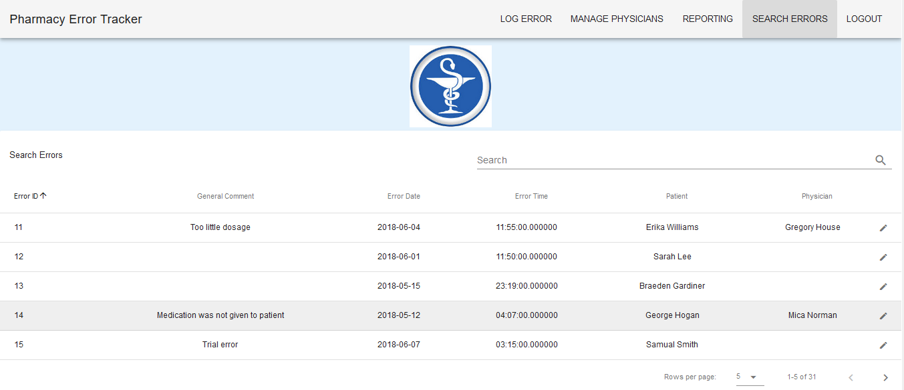

*Note: local database has Error ID values start at 11.*

Search is refined to search for Smith

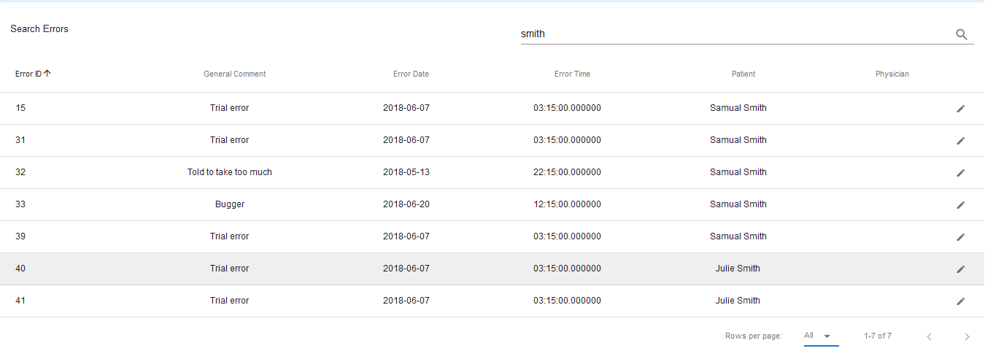

Error ID 31 selected to be edited. Current information from the server:

When Error ID 31 is selected from the search, the information is loaded into the Error Form:  
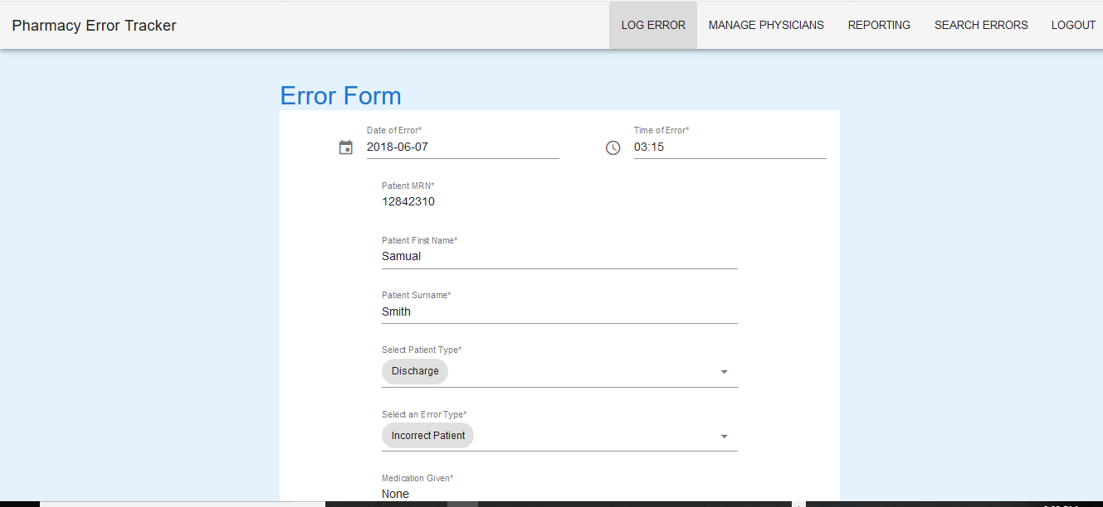

Details to be changed:

Date: 2018-06-07 > 2018-07-06

Time: 03:15 > 06:50

Patient First Name: Samual > Samuel

Patient Type: Discharge > Inpatient

Medication: None > Panadol

Comment: Trial Error > Incorrect medication

Error detected: Outside Hospital > Dispensary

IIMS completed : No > Yes

Severity Level: Low > Moderate

After Submit Button is selected, message returned:  
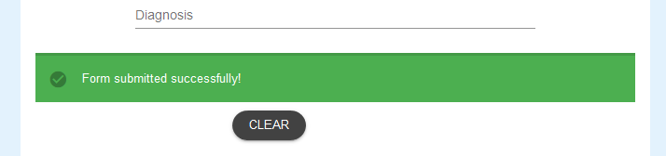

Details from Server:

Before After  
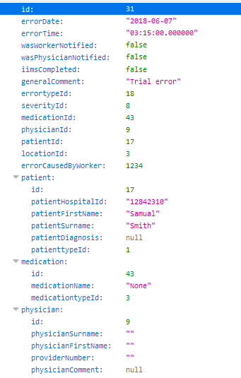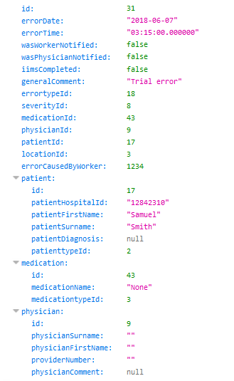

Failure as only the Patient first name and Patient Type Id have changed. Other details changed in the form remain the same.

Details as sent to the Server. Screenshot of Server Command Prompt Window.

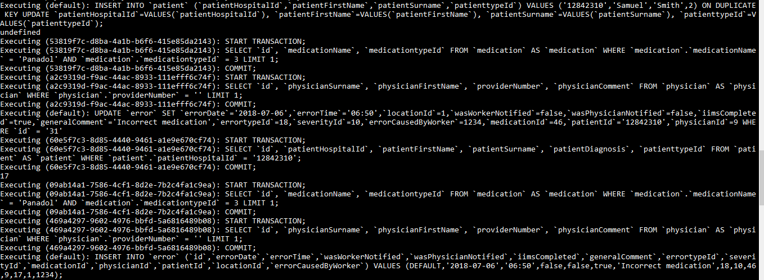

Updated details sent through to Server. Error in code did not allow updating of database. Code had findOrCreate instead of upsert as methods.

Issue found in the Error.vue file where the updateError and the logError functions were both being called.

Issue found in the query.js file where the updateError function was not correctly coded.

Fixed success message to return a different message when error added and when an error is updated.